### **A Honeycomb Pumpkin Decoration for Fall**

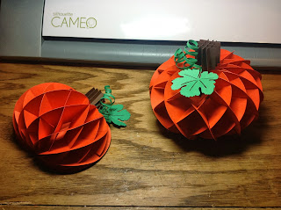

I made two different versions of this pumpkin. One for a bulletin board with a flat side and the other as a tabletop decoration.

This weekend we went to see the movie, Captain Phillips. We walked past a party room at the movie theater and on a table was a tissue paper ball in the center of the table. The ball reminded me of a torus with its honeycomb structure. I was always fascinated by the tissue paper decorations with their honeycomb shape. I remember as a child looking at it and wondering how was it made. The movie was riveting and Tom Hanks was wonderful as usual. I would highly recommend going to see the movie. When I got home, I wondered if I could create a pumpkin centerpiece using the torus structure and I did it. Here is the result.

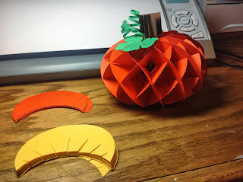

I measured each angle. The first slit is vertical at 90 degrees, the next slit is 25 degrees from the first slit (I used the Silhouette software to create the one slit at this angle and then did a mirror left). The next two slits are at 24 degrees and 21 degrees, respectively from the previous one. If you overlap both of the torus shapes exactly, you will see that they intersect one another. This is how they slide into one another to create the honeycomb shape. The slits are very tight so that the paper will not slide around. You might have to push a little in order to align the pieces together.  
  
I used cardstock for the pumpkin. The files only contain one of each type of torus slice. Cut eight of each type to make half of a pumpkin for a bulletin board or 16 of each type to make a desktop pumpkin.  
The two long narrow strips are to make a curly vine. You can wrap the strip around a pencil to create the curly affect.  
  
Here are the directions to put the bulletin board pumpkin together. Follow these directions for the centerpiece pumpkin...they are the same except for the extra pieces that need to be added. The key is to start in the center and end in the center for both pumpkins. When you get to the center of both sides in the centerpiece pumpkin, pick up the stack and connect both ends by sliding in the additional pieces to make it into one continuous round pumpkin.

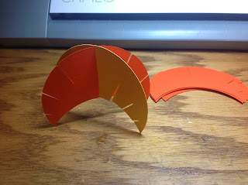

The two pieces slide together starting with the center piece.

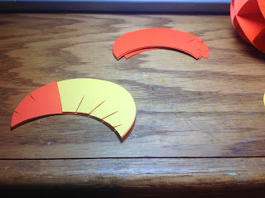

Lay the pieces flat on the table and start adding to the left side. The yellow piece was added.

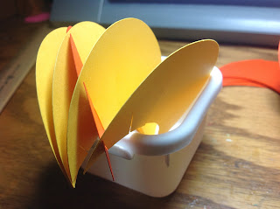

Repeat until you get to the end. It should look like this when spread apart.

Flip the stack over to the other side. Continue adding the pieces until the end. It should look like this.

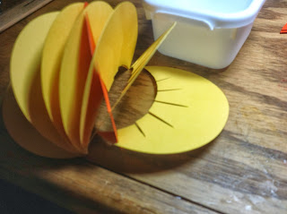

Take the piece with the top slits and connect the like slits in each consecutive piece in the stack until the entire piece is connected. It will look like this.

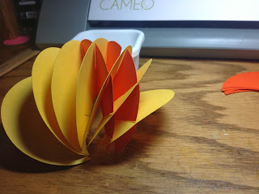

Next piece to be added.

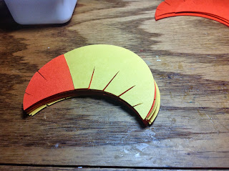

Keep the stack flat on the table and lift up the next piece. Always realign the entire stack so that it remains in alignment. After you connect the middle piece and it looks like this.

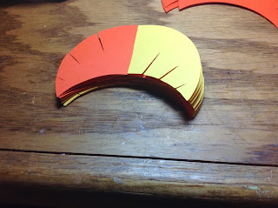

Turn the stack over and repeat the procedure until you do the middle slit. Here it is completed.

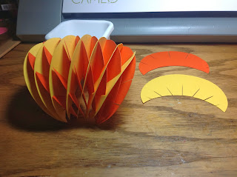

Glue the torus to the pumpkin shape.

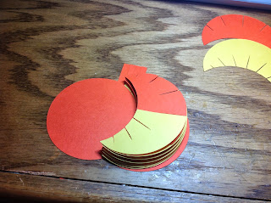

Add the stem by sliding the pieces together as shown below.

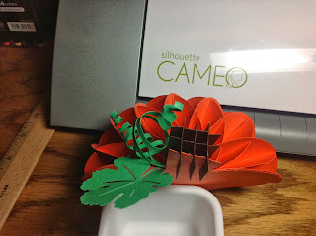

The centerpiece pumpkin stem is attached to the middle of the pumpkin with glue.

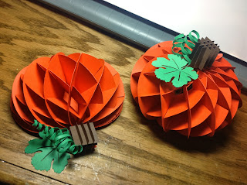

#sliceform #torus